*Accelerated Reader*

**Labeling and Dotting in School Libraries**

***Match the books to the labels, working across each bookshelf from left to right, top to bottom.***

Book labels are provided that look like this:

|  |  |
| --- | --- |
| 3SESL00009210K 152.4 A | Barcode # Call # |
| Feelings  Author: Aliki.  Reading Level: 2.0 LG  Point Value: 0.5  ACCELERATED READER QUIZ 9765EN | Title  Author  Reading Level  Point Value  Quiz # |

Labels are printed in the order that books are shelved in each library.

* Search for books by the call # (book location) – nonfiction (numbers), Fiction, Biography, Paperback
* Match the book title.
* Match the barcode # (usually on back of book - top).
* If you can’t find the book, put a √ next to the small label, indicating that you looked for the book and couldn’t find it but need to look again in the future.

***Attach the large label on the inside cover of the book.***

***Attach the small label on the bottom of the title page. Center this label.***

***Dotting***

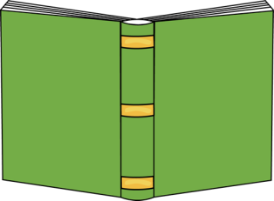Find the appropriate color dot for the **reading level** of the book:

1.9 and below – red 5.0 – 5.9 - lavender

2.0 – 2.9 - green 6.0 – 6.9 - yellow

3.0 – 3.9 - blue 7.0 and above – gray

4.0 – 4.9 - orange

Place the dot close to the TOP of the book’s spine.

Be careful to use the reading level number and NOT the points number to select your dot.

Books with bumpy covers will need a label protector to cover the dot. Most books do not.

**Note**: it’s possible that you might have duplicate labels. The way to tell if a label is a duplicate is if the barcode #’s are the same. Just leave duplicate labels on the sheet.

***Spanish/English Books***

* Attach the English label to the inside cover of the book.
* Attach the Spanish label directly below the English label.
* Attach the appropriate color dot for English on the spine label.
* If the Spanish dot color is different attach it directly below the other color dot.

**Library Services · Pinole Middle School, #A12 · 1575 Mann Drive Pinole, CA 94564 · 510-231-1436 ext. 26353 or 26356**